Changes ASR 6454

**From:** Agnes, Chong   
**Sent:** Monday, 05 December, 2016 12:03 PM  
**To:** Chan, Pei-Fong  
**Cc:** Jack, Fong; Yeo, Lance  
**Subject:** WMS Container Loading Sheet

Hi Pei Fong,

I need some modification to the attached document.

1. Removal of below rows

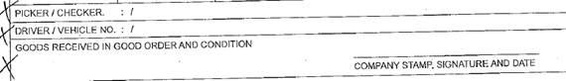

1. Add document title “Container Loading Sheet”
2. Remove non-related address.

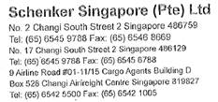

1. Update Ship From address:

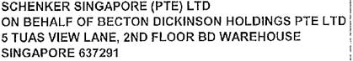

You can call me if you need clarification.

Thank you.

Best Regards,

Agnes Chong

Senior Executive

Contract Logistic/SCM

Deploy: 2016-12-29

Updated Storer

update STORER set Company = 'BECTON DICKINSON HOLDINGS PTE LTD' ,

Address1 = 'SCHENKER SINGAPORE (PTE) LTD ON BEHALF OF' ,

Address2 = '5 TUAS VIEW LANE' , Address3 = '2ND FLOOR BD WAREHOUSE' , Address4 = 'SINGAPORE 637291'

where StorerKey = 'BD'

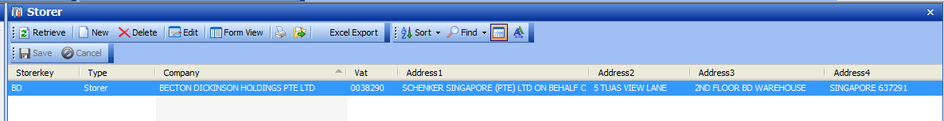

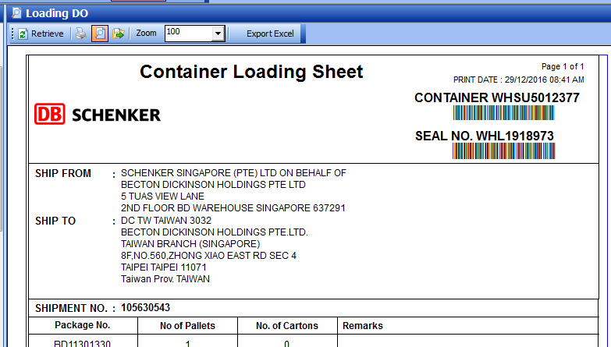

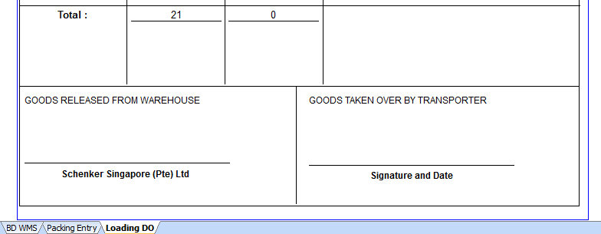

Packing List – no change

